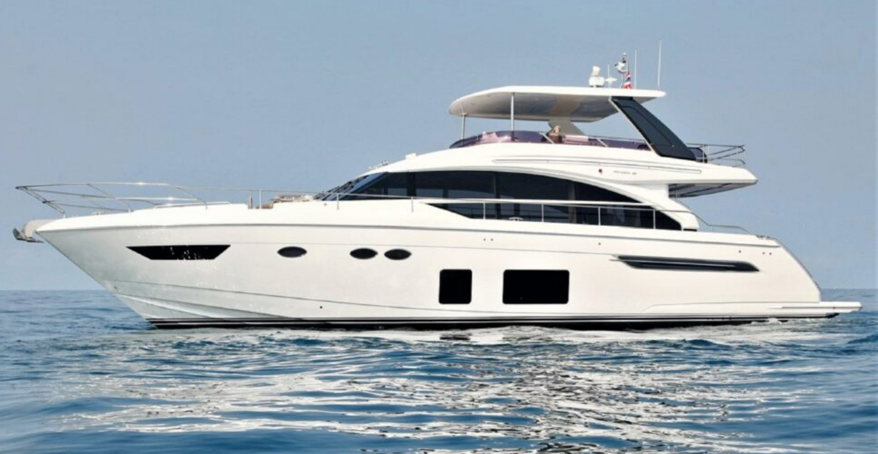

Yacht Rental Quote

Princess 68Y 2016

**Overview**

The Princess Flybridge yacht features an impressive internal volume for a yacht of her class and stunning entertaining space when out at sea and in the sun. As you walk into the main saloon and lounge, you will have incredible views on the surrounding seas and plenty of natural light from the massive full height windows. The 68’s master suite features a private staircase and lobby, the guest cabins being accessed by a separate stairwell forward. The full beam master suite includes a bathroom and dressing area with vast windows for the most impressive views.

Length: 70ft

Beam: 18ft

Draft: 6ft

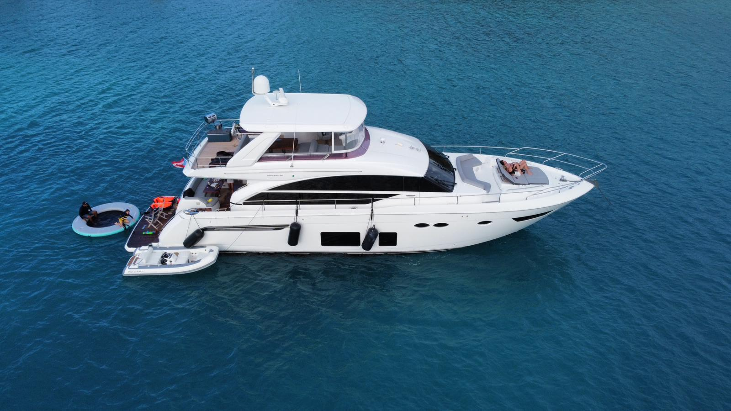

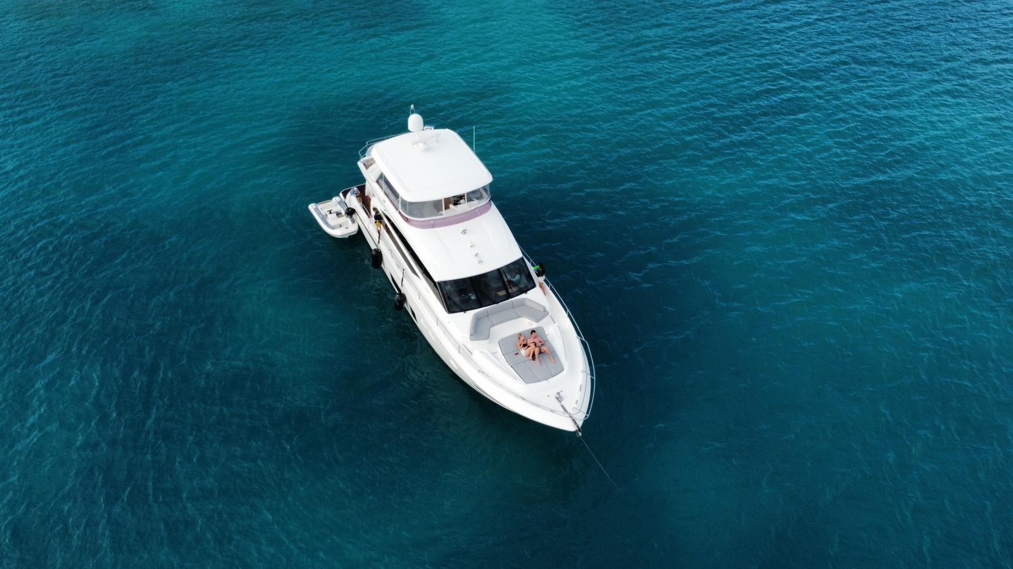

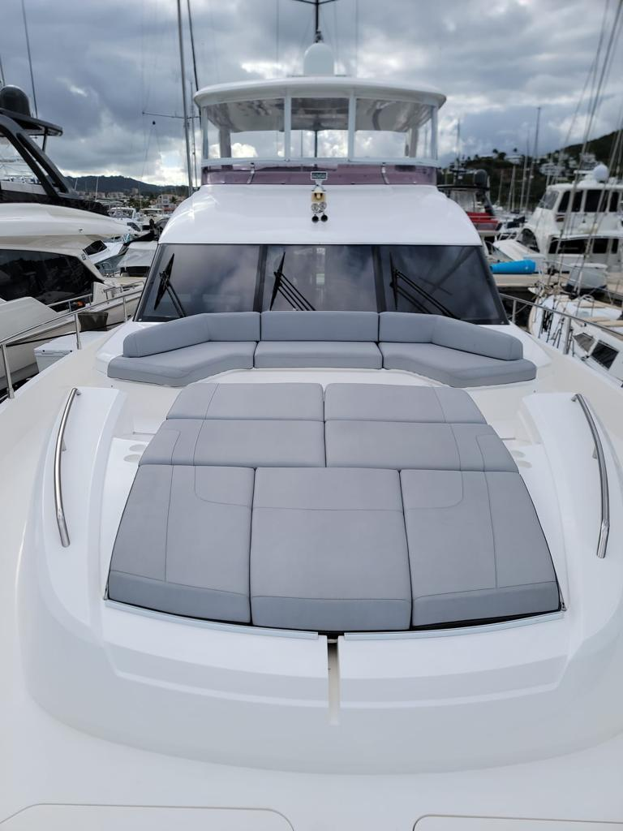

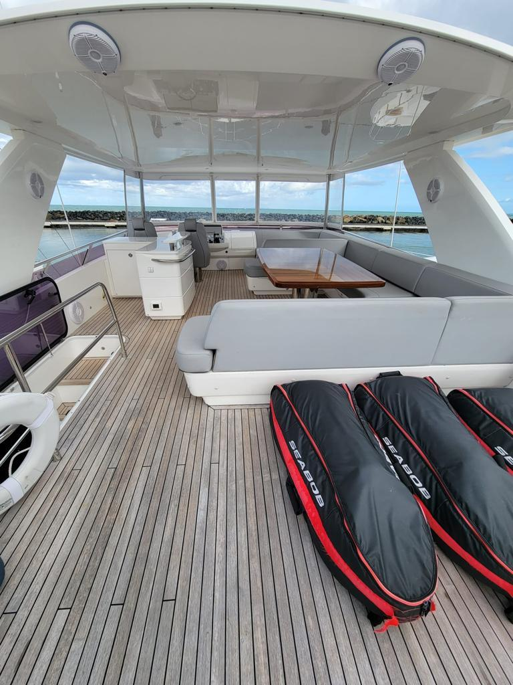

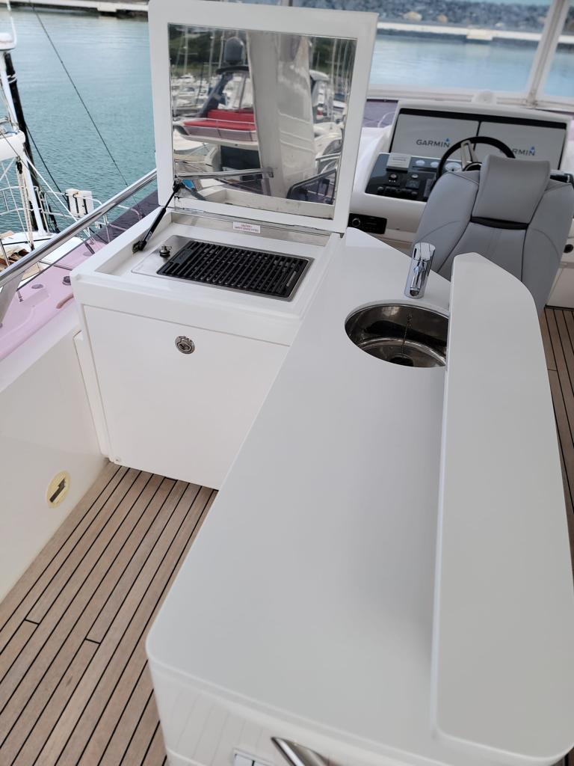

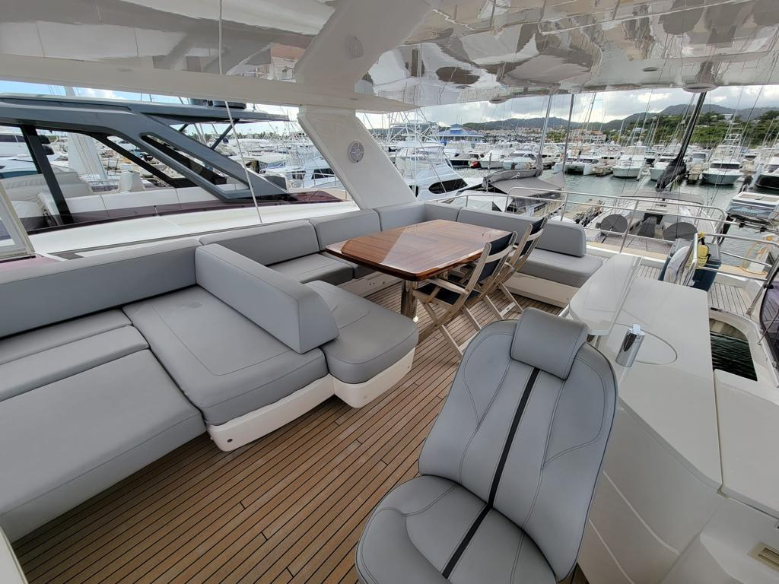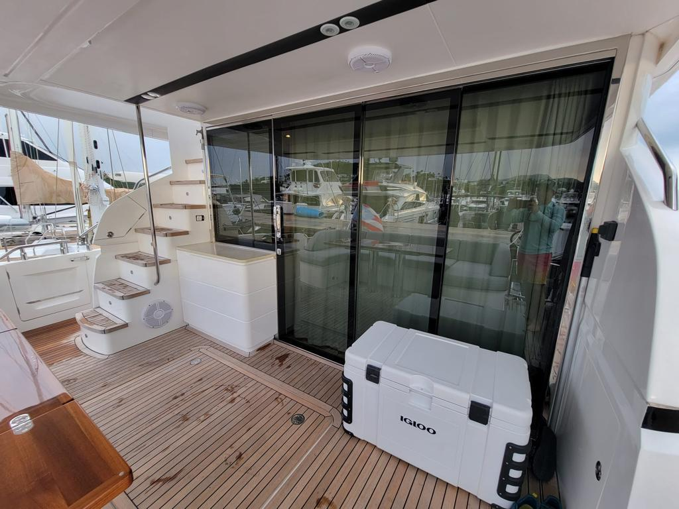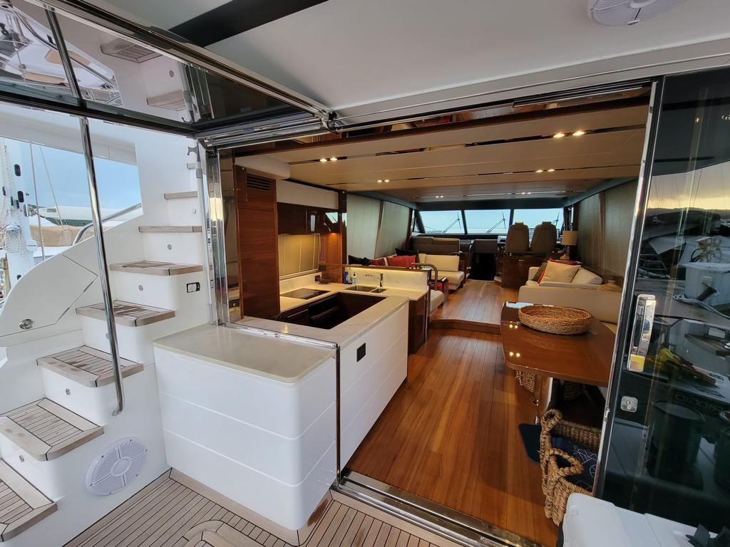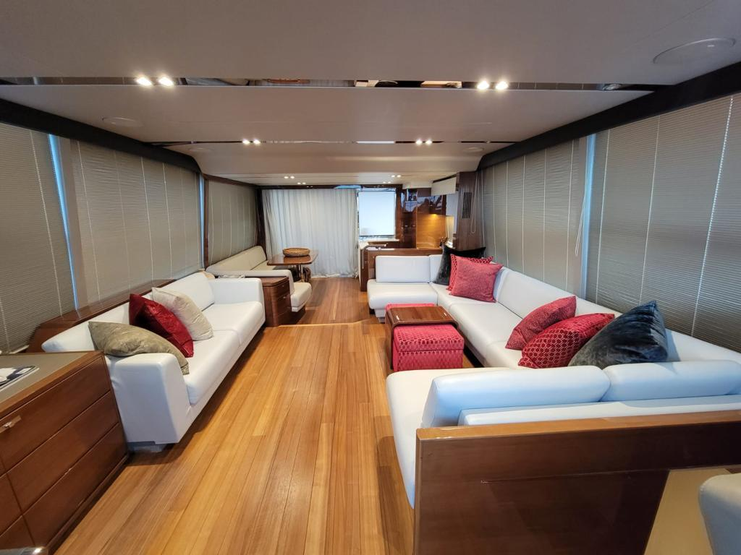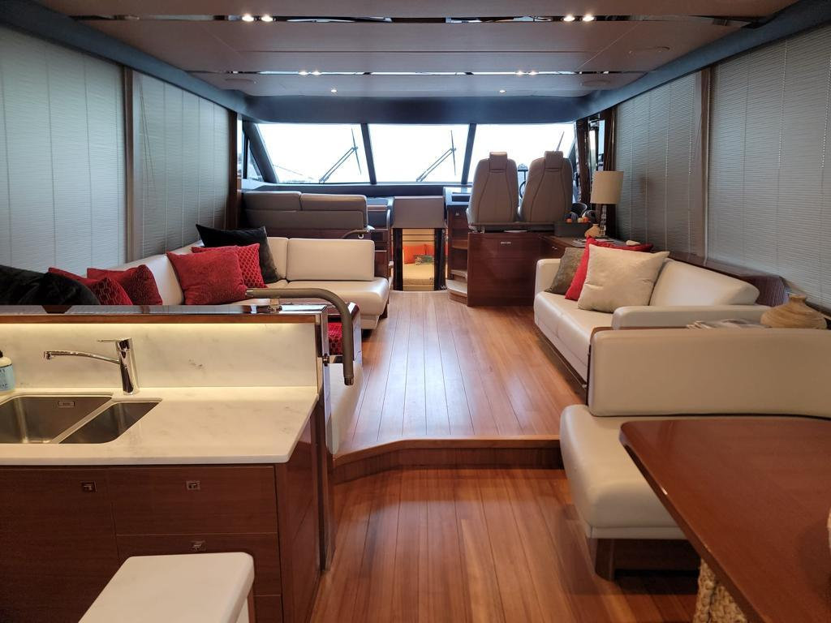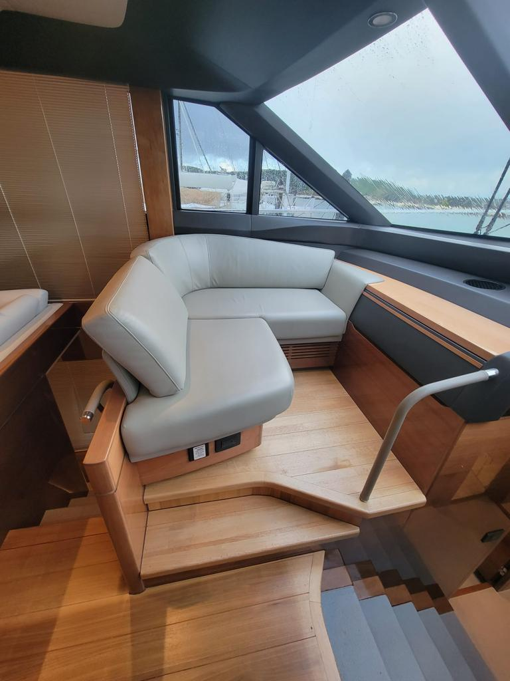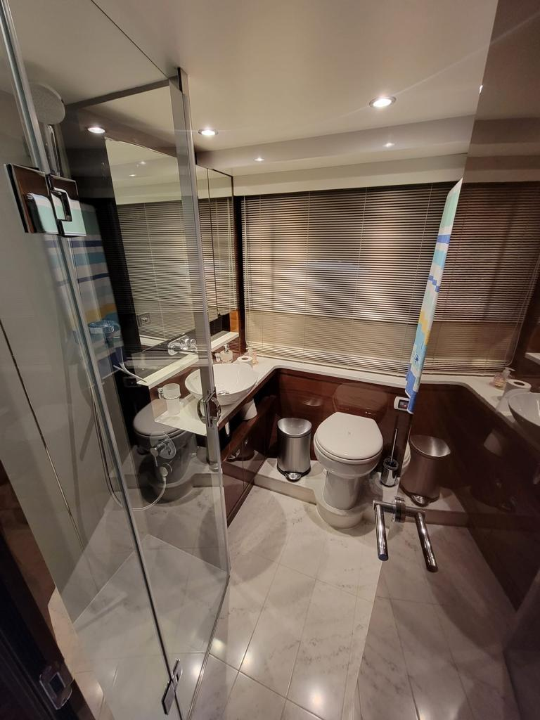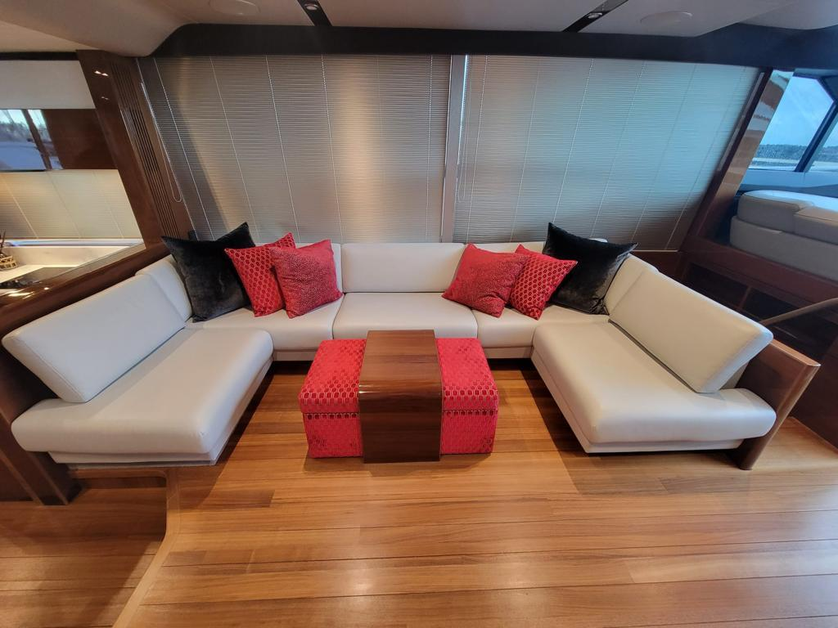

$36,000 plus 11.5% sale tax